Output Log Instructions
What is an Output Log? Why is it important?
Output logs are the tool you will use to submit your work accomplishments to SCA. We use this data you provide for a number of important reporting purposes:
- Showing our partners your accomplishments during the project. While your site supervisor knows these details, SCA must report your accomplishments to other partners involved.
- Reporting your accomplishments to funders, who help make the programs possible.
- Demonstrating the collective impact of SCA across its many programs and locations. For an example of how this data is used, please see one example here.
This is why your timely and accurate submissions are necessary for your continuing position and SCA’s vital reporting needs.
Who fills out output logs?
Interns: All interns should be filling out output logs for their work accomplishments. If you are working on the same project with other SCA’s, only one of you will need to complete an Output Log for each group accomplishment. Use the “Total number of SCA members and leaders” (seen below in the screenshot) to indicate the number of others working on the project with you. You can also use the description box to include the names of the other interns you worked with.
Crew Leaders: As the leader(s) for your crew, you are responsible for filling out the work accomplishments for your crew. Only one leader needs to complete the output log. This includes if your crew worked with another crew on the project; only one leader per accomplishment, not one leader per crew. It is super important that work not be duplicated in the output logs, so make sure to coordinate who fills out the log for each work accomplishment so there are no duplications of the work.
When do I submit output logs?
Because SCA has to report on your work throughout your position, we need you to submit logs on a regular basis. How often we need you to report depends on the type of work you are doing:
- For work you do on an ongoing basis through your position, such as interpretation or visitor center contacts, please submit a log at least once every two weeks, with your numbers for each two week period. If you track your recurring work on a weekly basis, feel free to submit on a weekly basis.
- For work conducted as discrete projects, such as trail improvement or writing curriculum, please submit a log any time you complete a project or major task (i.e. finishing a data collection report, or tabling at a community event).
At the end of your position, check to see that all your work accomplishments have been reported. You can find your submitted time logs in the “View My History” tab. You may also use the “View My History” tab to complete any outstanding logs you have not yet submitted.
How do I submit an output log?
Output logs are completed in your MySCA portal. Once there:
- Go to “Manage My Service Tasks” (If the position that you're looking for has an end date that has already passed, instead click on “View My History”)
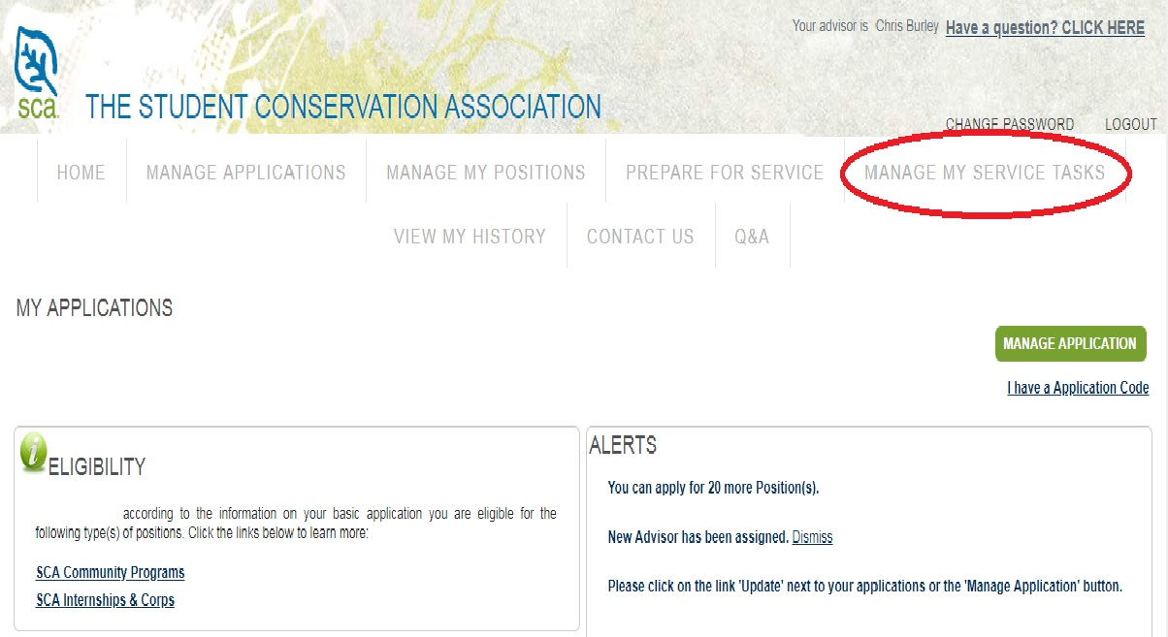
- Find the position you are reporting on. Click the position number on the left
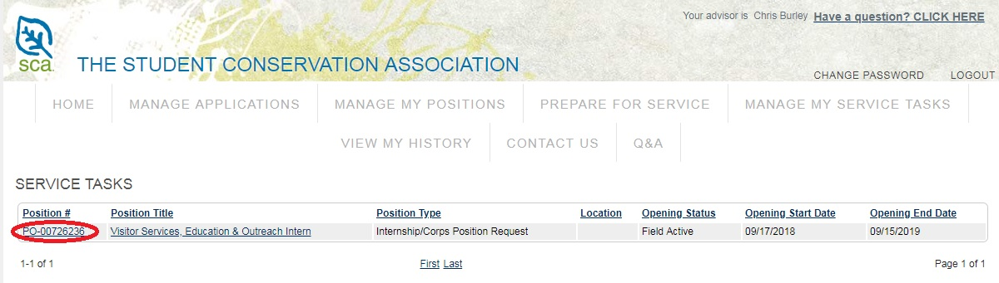

- Scroll down to the Green box (right hand side) that says “New Output Log”.
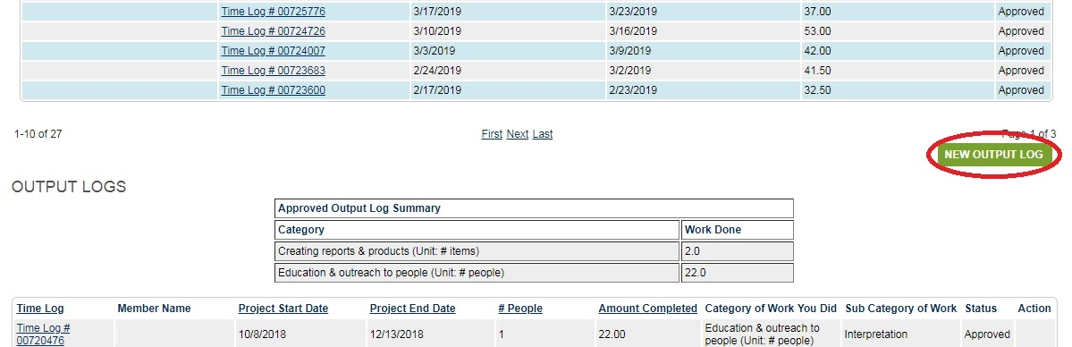

Once you select “New Output Log” the below form will appear. Each red number represents a box you need to complete.
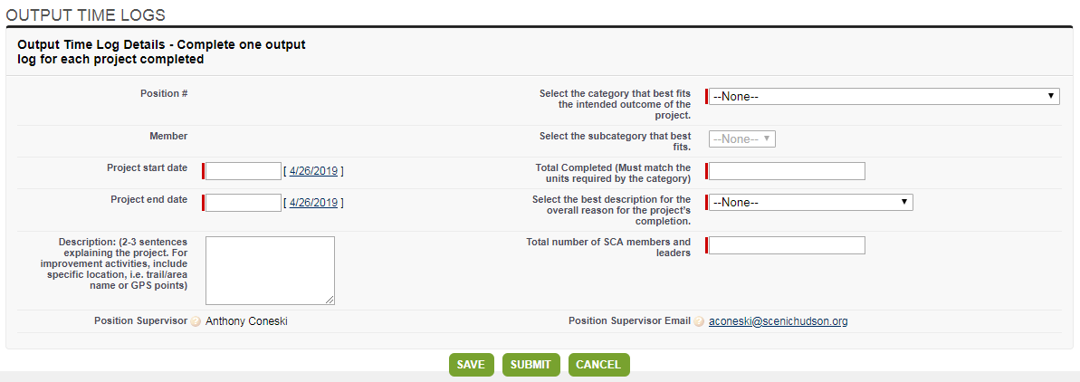
8

7

1
6

5
4
3
2
- Enter Project Start and End Date
  - Date this specific project was started and completed. Project should be completed before submitting an output log. For the purposes of SCA output logs, we are only interested in the final product and do not need separate logs for all the individual steps of the project.
  - Tip: It is ok if the project work was not continuous during the start and end dates (for example, if you only worked on the project intermittently during the date range). Just put the first date you began the project and the final date you completed the project. Feel free to note in the description that the work was only completed intermittently.
- Select the category that best fits the work you completed
  - In selecting the category, remember to consider the bigger purpose of the work: what is the intended outcome of the project?
  - If your project included multiple categories of work (such as “Education and outreach to people” and “Improving Trail”), please complete a separate output log for each category of work.
  - Tip: If you select “Leading volunteers in service”, make sure to create an additional log for the work that you completed with the volunteers.
- Select the subcategory that best fits
  - If multiple subcategories describe your work, select the one you spent the most time on. In the description box, please indicate the other types of work that you completed as a part of this work project.
  - Tip: Please avoid using “other” unless no other category/subcategory can possibly fit. Using the description box to capture the details is important in sharing your accomplishment.
- Total Completed (must match units required by the category)
  - Enter the measurement of how much work was accomplished.
  - Number MUST be reported in units required by the category
    - Ex. Improving Land requires # acres – do not report # square feet, square meters, hectares, or other area measurements
    - Ex. Improving Trail requires # feet – do not report # miles, meters, yards, or other linear measurements
  - Duplication: Never report on the same accomplishment twice. The # people, # feet, # acres, # buildings or other #’s should never overlap with other output logs that you create.
    - Ex. If you cleared trash on 2 acres, and then later you removed invasive species on the same 2 acres, you should only create ONE output log tracking those 2 acres. Choose the sub-category that took the most time or had the greatest impact, and write in the description that you did both types of work on those two acres.
  - Tip: There’s a great tool you can use to convert from one unit of measurement to another: http://www.metric-conversions.org/.
- Select the best description for the overall reason for the project's completion.
  - While there may be multiple reasons that could describe your project’s importance, choose the one that you feel highlights best the “why” part of this particular work project.
- Total number of SCA members and leaders
  - Enter total number of SCA participants working on the project. This includes any other interns, crew members, or other SCA crews that worked on this work accomplishment.
  - Non-SCA members should not be counted here, but can be mentioned in the description box.
- Description
  - Use this space to describe more details about your work accomplishment:
    - Where was it? (Which park, trail, forest, etc.)
    - What was the specific type of work?
    - What is better off or made possible as a result?
    - What was a highlight?
  - For the “Education and Outreach to people” category, please include:
    - In what context was it (visitor center, classroom, etc.)?
    - What were you educating about?
    - What was a highlight?
- Submit Button
  - Click “submit” to send the Output Log to your supervisor for approval
  - Only use “save” if it is likely the project is incomplete and will need to be updated before submission. Just remember to submit it before the end of your program!
Managing Output Logs
Once you have completed and submitted an output log, it will appear in your "Manage My Service Tasks" below the "new output log" button, as can be seen in the screenshot below.

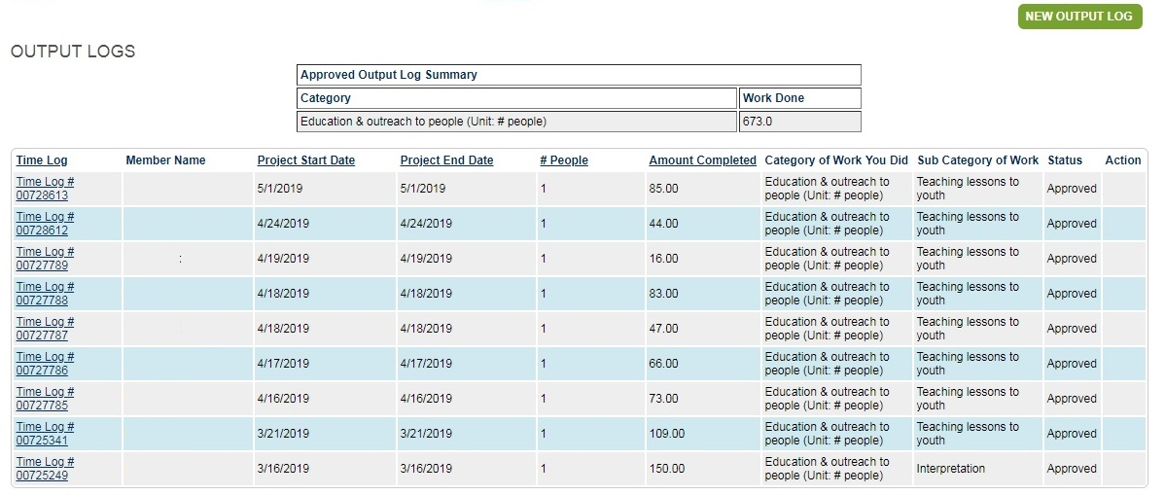
4
1
3
2

- There will be an "Approved Output Log Summary" section that summarizes the total amount completed for each Category of Work
Tip: This summary can easily be copied/pasted into a word processor, spreadsheet, etc. to save a copy of your position’s accomplishments
- In addition to the summary, there will also be a list of all the output logs you have created for your position, along with a “status” and “action” column.
- The “status” of your output log can include:
- Draft – Output Log was “saved” by whomever created it but has not been submitted
- Submitted – Output Log was sent to supervisor for approval
  - For interns, this is your site supervisor.
  - For leaders, this is your program manager.
- Rejected – Output Log needs to be edited and resubmitted to supervisor
- Approved – Output Log was accepted and will now appear in the summary table
Tip: This output log list can be sorted by time log number, project start or end date, number of people, or amount completed by clicking on the associated headers.
- The “action” of your output log can include:
- Submit
- Edit
- Delete
Tip: If you catch a mistake on your output log, but have already submitted it, ask your supervisor to “reject” the time log, which will make it editable for you again. If your supervisor has already approved the log, go to the “home” page in your portal and click on the, “Have a question? CLICK HERE” and submit a help request through that link.
My position has ended. Where can I find my output logs?
Once your position has ended, your time logs will move to a tab called “View My History” (instead of “Manage My Service Tasks”). Click there, then on your position hyperlink, and you will find your time logs.

Still have questions?
Reach out to SCA staff:
- If you are an intern, reach out to your advisor with additional questions and help.
- If you are a crew leader, reach out to your program/team manager.

