As soon as you activate your US Bank card you can begin to use it. However, you won’t be able to code your charges or request reimbursement until you receive your Nexonia login. The instructions below detail how to use Nexonia to code charges and request reimbursements for mileage and other expenses.

Getting Started

If you have a US Bank card, and you have created a Paycom profile (payroll system), you will be emailed a link to “reset your password” with Nexonia. (Please note that if you start the last week of the month you will receive your Nexonia login at the beginning of the next month.)

TIP: This email will be sent to the email you used in your Paycom profile, which might be your personal account. (Check a junk folder if you don’t see it.) This email may just say “Reset your password” even if you haven’t set a password up before.

For your first time logging in will need to take place on a standard web browser (like Chrome, Explorer) on a computer. After you reset your password, you can download the Nexonia app, and all future expense reports can be filed and submitted via the app or through a web browser.

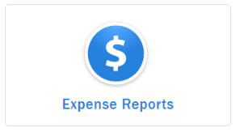
Coding Expenses

To start: Click Expense reports

Then select Add Reports
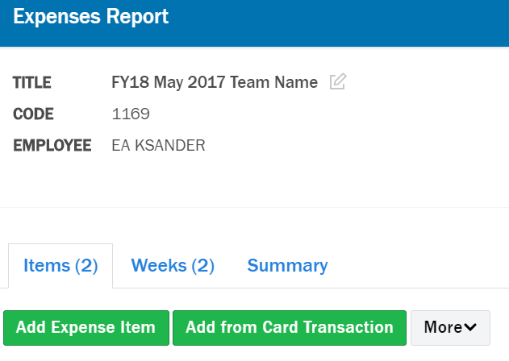
A box will appear to title your report.
Please use the following naming convention:
[FY22] + [Date range of Transactions] + [Team Name or PO for team]
Example: FY22 April 1-15 Los Padres Fuels Team

TIP: The title should be a prompt to jog your or your supervisor’s memory as to what these expenses are for.

Each expense report includes two ways you can report expenses: Add Expense Item or Add from Card Transaction

TIP: Before you begin coding transactions, collect together all of your receipts. You will not be able to save coded transactions without receipts.

1. Add from Card Transaction – Choose this when:

- You used your SCA-issued US Bank card to pay for items for your project or position.
- TIP: Most of your submissions will take place in this section.

2. Add Expense Item – Choose this when:

- You need to be reimbursed for using your personal money to purchase something for your team on behalf of SCA.
- You need to submit mileage reimbursement when you used your personal vehicle to travel to your site or training.

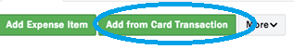

1. Add from Card Transaction: Follow the process below when you used your SCA-issued US Bank card to pay for items for your project or position.

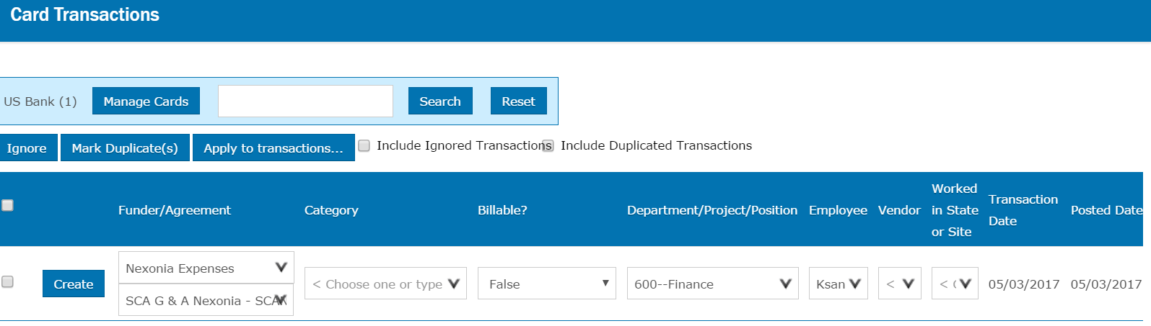
After you click this button, a list of charges on your US Bank card will display.

What do I do if I don’t see a charge I made listed in my card transactions?
Wait until next week. If a charge doesn’t show up, it can be delayed because of the US Bank to Nexonia sync (which happens every Monday) and/or the merchant’s submission of the charge, which can be several days after the transaction.

To get started coding your expenses, choose an expense and click the blue Create box on left.

The Add Expense Item pop-up box will appear.

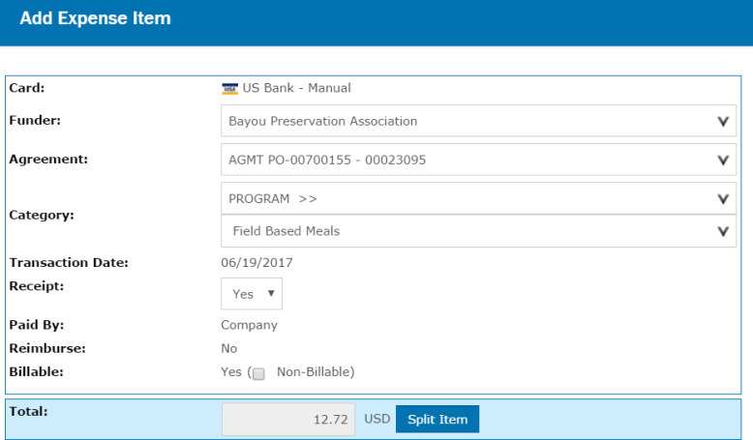
Enter the Funder and the Agreement number that your program manager provided you when you received your budget. It is essential that you populate these fields with the correct Funder and Agreement so that your expenses can be billed accurately.

TIP: If only one Agreement is active with that funder, it will automatically fill here. If more than one is available, confirm that the one you select from the dropdown is the one your program manager provided.

For Category, select Program to show it is an expense related to executing program.

A second drop down box will appear and will provide options for you to select the type of expense your item relates to: Postage, Lodging, Field Based Meals, etc. This is the Expense Type. Select the category that matches the type of purchase you made with your card. If you are unsure of the best category for your charge, ask your Program Manager for clarification.

For Receipt, always choose Yes. All expenses must be accompanied by clear and legible receipts. See the Linking Receipts section below for more information about receipts.

At the bottom of this section Billable should always say Yes at the end of this section. (TIP: If it defaults to Non-Billable, check the checkbox to change to Billable.)

Total will pre-fill from the charge.

If you need to split a charge, click Split and you can divide the charge into multiple expense types (i.e.: $20 to meals and $20 to supplies) or divide it by multiple funders or multiple agreements (i.e.: You buy a case of gloves and split them between two teams with different funders).

On the section BELOW the total line:

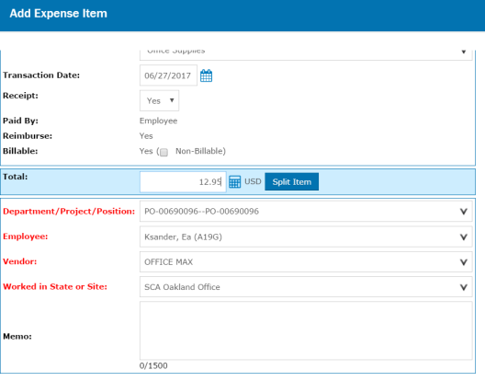
In the Department/Project/Position field: Enter the position number for your crew. This starts with PO- but if you know the number, you can just start typing it in and it will shorten the drop down list until it only contains your number (Example, if your team’s position number is PO-616996, you can just start typing 616…and select when you see your Position or keep typing until the selection has nothing but your number.

In some cases you may be given a Project number instead, follow the guidance of the Program Manager. These will have a PR- prefix.

Employee: This should be you in this field.

Vendor: You can start typing the name of the merchant on your receipt. If it was a very common merchant, it will filter and you can select that. If the merchant is less common, find the “generic” for the general category of merchant you visited, “Hotel, Other”; “Parking Authorities” (any parking garage or meter); “Restaurant, Other”; etc. TIP: Pick a choice that matches the type of merchant as close as possible; this is the only field on the expense report that doesn’t have to be perfect.

Worked in State or Site: Use your Park or project site if listed. Enter your State if not. Like other fields, if you start typing the name of the site, it will narrow the list available to select.

Memo: This may auto fill from the transaction info. Below the autofill info, write a brief explanation of the purpose of the expenses. TIP: Provide clarity here if the name of the merchant coming over on the transaction and the name on the receipt are different. This may occur if multiple merchants share a credit transaction account. Your manager may give you more specific guidance as to what to include in the memo section as well.

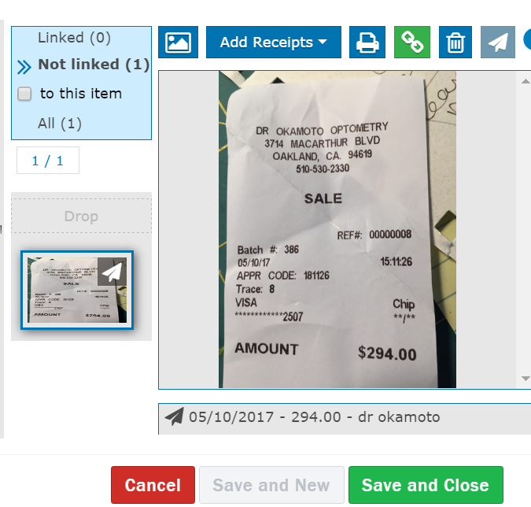
Linking Receipts

For every transaction, you must attach a digital copy of the receipt captured via your phone’s camera, scanned at your office printer as a PDF or sent via email from Merchant (Square). It is a good practice to capture a receipt as soon as you can after the transaction.

Your receipt copy should be clear and legible. It must include the transaction total, vendor name, last 4 digits of credit card, transaction date, and itemized list with detail of purchase. All restaurant purchases require two receipts: both the itemized receipt and the receipt with the tip and total amount.

Once you have the correct receipt viewable, click on the Green “Link” icon above the picture of the receipt to link it to the transaction. If the receipt has multiple images, continue adding additional links until the entire receipt is linked to the transaction.

Click Save and Close when you are finished.

If you lost your receipt or did not receive one for the transaction, you must contact the vendor and get a new copy. SCA cannot be reimbursed by its partners for expenses that aren’t accompanied by receipts. If you are unsuccessful at securing a receipt, contact for your program manager to troubleshoot.

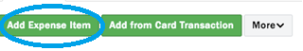

2. Add Expense Item – Choose this when:

- You need to be reimbursed for using your personal money to purchase something for your team on behalf of SCA.
- You need to submit mileage reimbursement when you used your personal vehicle to travel to your site or training.

Entering Expenses for Reimbursement

If you have used your own money to cover an SCA expense, Click Add Expense Item.
The pop-up box will look identical to the Add from Card Transaction pop-up box.

Follow the instructions in the Add from Card Transaction section above to populate the information.

When submitting expenses for reimbursement, please also note the following:

Transaction Date: Enter the date of the expense being reimbursed for. (It will auto fill with today’s date, so this will need to be adjusted manually.)

Receipt: You must always choose “Yes”. For every reimbursement you will need a clear and legible receipt that includes the transaction total, vendor name, transaction date, and itemized list with detail of purchase. All restaurant purchases require two receipts: both the itemized receipt and the receipt with the tip and total amount.

TIP: Always capture an image of your receipt as soon as you can after the transaction. If you used cash, this will be especially important! Even if you put $50 in a parking meter, take a photo of the parking terms to upload as your reimbursement receipt. Ask a vendor to write a hand-written receipt with the necessary information if you need to.

Memo: For a reimbursement, use the memo section to explain where, when, why the purchase was made. This is especially important for expenses you attached for actual reimbursement to you (Why was your SCA-issued US Bank card not used?) to ensure that your reimbursement request is approved. This field is critical when not coding a charge from a card transaction.

Linking receipts: See the instructions above for details on this step.

Click Save and Close when you are finished.

Submitting Mileage Reimbursement

Submit a mileage reimbursement when you used your personal vehicle for travel related to your program/project.

Click Add Expense Item. The pop-up box will look identical to the Add from Card Transaction pop-up box.

Enter the Funder and Agreement, follow the same directions above in the Add from Card Transaction section.

For Category, select Program and then Leader – Mileage.

Transaction Date: Enter the date of travel.

Both Receipt and Billable should say “Yes”.
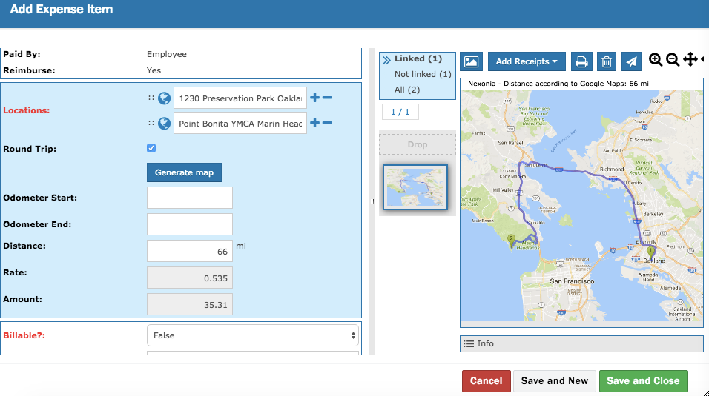
In the blue section, enter the details about the distance for which you are requesting reimbursement.

Location: Enter your start and end points. Use the Plus and Minus symbols to add or remove Way Points along the way (did you stop by the cache? Did you pick someone up?) All of these deviations will be added to your mileage map to determine the complete distance you traveled.

Click Generate Map. A map of your trip will appear, automatically linked to the expense item.

If your return trip was a mirror return, check the blue Round Trip box to double the miles without additional work.

Distance, Rate, and Amount will populate automatically.

Odometer Start and Odometer End: Leave these fields blank. Only populate these fields if you are unable to map your trip using the location mapping above. TIP: This might be the case if your Google map can only capture the address of the park headquarters but can’t capture the extra 8 miles you drove to your campsite in the park. Entering odometer reading for that portion of the trip would be appropriate.

Department/Project/Position: Same as directions above in the Add from Card Transaction section.

Employee: Same as directions above in the Add from Card Transaction section.

Vendor: Choose Mileage-SCA.

Worked in State or Site: Same as directions above in the Add from Card Transaction section.

Memo: Use the memo section to explain where, when, why of the trip.

Click Save and Close when you are finished.

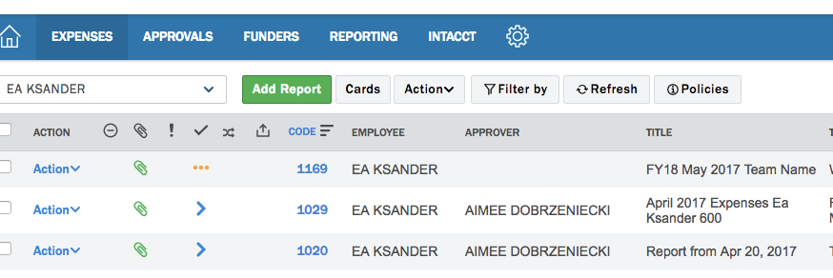
Submitting Reports for Approval
Back on your main Expenses screen, you will see a list of your reports.

- Submitted reports will have a blue > sign (see bottom two rows of above screen shot)
- Draft reports will show three yellow dots … (see top row of above screen shot)
- Rejected reports will show a red > sign. Look for an email with an explanation of what needs to be corrected and resubmitted (e.g., a receipt is not clear or a vendor name is not showing)

From this list, under the Action drop-down menu, you can edit (code additional expenses), delete, or submit for approval any reports still in draft.

After you have completed a report by coding all expenses from card transactions, submitting applicable reimbursement requests, and any mileage reimbursements, you are ready to submit for approval.

Click on Action and select Submit.

If you requested reimbursement for mileage or other expenses, payment will be made via check to your address in Paycom. TIP: You can adjust this to receive checks delivered to wherever you specify, but be sure to update your address by end of season to get last expense checks mailed to where you can receive them after your program closes.

If you will receive a credit for a cancelled transaction, hold off on submitting your report until the credit goes through, then submit the report with both the original charge and the credit.

Nexonia Worksheet

Work with your Program Manager to fill out the following worksheet to guide you through the information you’ll need when you code in Nexonia based on your program budget.

Funder: __________________________________________

Agreement: ______________________________________

Category:
- Program: Field Based Meals
  - Snacks for crew, crew meals, food purchases
- Program: Field Supplies
  - Equipment, general supplies for workdays/activities, admission tickets
- Program: Vehicle Gas
  - Gas purchases for truck
- Program: Member Commuting
  - any parking garage/street parking/meter/toll
- Program: _________________

Department/Project/Position:

PO-00: ______________________________________

Worked in State or Site: __________________________________

Memo:
Examples of memos that describe the purpose of the transaction:
"Purchase of gas for truck”, “Purchased extra work gloves and eye protection”

________________________________________________________________

Most Commonly Used Vendors

Food/Field Based Meals:
First type in the name of the restaurant or store and see if it is listed. If not, then generally it can be placed in one of the following categories:
- Café & Bakery
- Bakery, other
- Coffee Shops
- Costco WHSE
- Farmers Market
- Food Coops
- Grocery- Other
- Pizza Shops, MISC
- Restaurant Other
- Target
- Trader Joes
- Wal-Mart
- Walgreens
- Whole Foods Co.
EE day/camping activities can generally be placed in one of the following:
- Camp Grounds
- Canoe and Kayak
- Citi bike program
- Indiana Dunes Nat Lakeshore
- Museums and Stores
- Recreation and Parks
Hardware/tool/supply purchases can generally be placed in one of the following:
- Forestry Suppliers
- Hardware Store
- Home Depot
- Lowes
- Outdoor Gear Stores, other
Gas purchases can be placed in one of the following:
- Citgo
- ExxonMobil
- Gas- Other (please select this option if it was a gas station not listed here)
- Phillips 66
- Pilot Travel Centers
- Shell Oil
- Speedway
General stores or categories for field supplies:
- Bookstores
- Camping gear
- Craft Supply
- CVS/Pharmacy
- Dollar General
- Dollar Tree
- Family Dollar
- Michaels Stores
- Office Depot
- Office Max
- Rite Aid Store
- Staples
- Target
- Trader Joes
- Wal-Mart
- Walgreens
- Whole Foods Co.
Any parking garages or meters should be labeled as:
- Parking Authorities
Rideshare or transportation categories:
- Bus/streetcar/trolley (this can be used for CTA fare or passes)
- Lyft Ride
- Mileage-SCA (this should only be used for reimbursement for personal car usage)
- UBER
Any postage or mailing can be labeled in the following categories:
- FedEX
- UPS
- USPS

