Insert Title of Program or Team
  - FINAL REPORT (INSERT Agreement Number HERE- To be completed by SCA Staff)
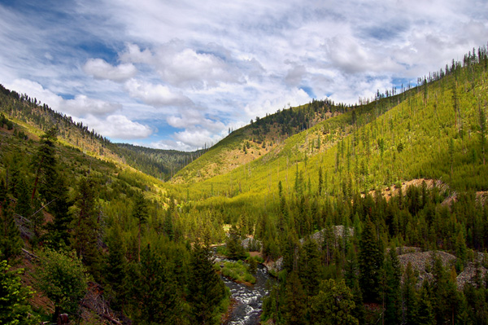
  - INSERT photo of entire crew posing in front of project – make sure faces and SCA uniformed are visible

INSERT Program Year

INSERT Location Name or Agency

Program Dates: INSERT Start and End dates

Leader(s): INSERT Leader Names

Executive Summary

The mission of SCA is to build the next generation of conservation leaders and inspire lifelong stewardship of our environment and communities by engaging young people in hands-on service to the land. SCA was founded in 1957 by Liz Putnam, a college student who believed that the passion, talent, and hard work of young people could be a force for tackling the challenges facing America's public lands. Today SCA provides opportunities for thousands of young people to develop conservation values and explore pathways to green careers, strengthen their leadership skills, and deepen their sense of responsibility to others and to the world. Young people emerge from SCA with fuel for their continuous growth and with a sense of empowerment to take action for the issues that they care about, in conservation and beyond. SCA nurtures thriving youth and thriving landscapes.

  - INSERT 1-2 paragraphs on overall purpose of your team:
- Where were you serving?
- Were the any unique aspects to the partnership between SCA and our partners for this project?
- What was the purpose of the team?
- What was the unmet need of the agency?
- How did you meet those needs?

Conservation Impact

Through SCA, young people have the opportunity to complete meaningful work that makes a positive impact on the world around them. SCA projects make tangible and positive impacts to the land, protecting and restoring parks and public lands, educating visitors about conservation, and increasing access to urban green spaces.

  - INSERT a description of this team’s work objectives and whether they were met:
- What work was needed?
- What work did the team accomplish?
- Why the area is better off as a result?
- What is the local relevancy of the project? How does this serve the local community? Does it address any climate action goals, local restoration or environmental justice initiatives?
  - INSERT output log stats in the “Summary of Accomplishments” list below (add or delete relevant rows as needed). Create additional tables as necessary to capture AmeriCorps metrics (Corps only) or agency partner requested data, such as herbicide use or species descriptions.

Summary of Accomplishments:
- # people provided outreach and education: INSERT here
- # acres of land improved: INSERT here
- # feet of trail improved: INSERT here
- # feet of waterway or shoreline improved: INSERT here
- # structures built or maintained: INSERT here
- # trees planted: INSERT here
- Other: INSERT here

Participant Impact

In every SCA experience, participants complete projects that solve real conservation challenges and see the tangible results of their labor. Through this work they learn how to conserve resources and protect the planet, learn why their conservation work projects are critical to that effort, and discuss with teammates and leaders what they could do to address environmental issues after SCA; including exploring possible careers in conservation or green jobs and discussing their academic and career goals. SCA experiences provide participants with opportunities to lead their peers, engage in problem-solving, conflict resolution, and group decision-making, and ultimately reflect on the ways the experience is impacting them.

  - INSERT 1-2 paragraphs describing the activities you did on your team to make it a positive, beneficial experience for your members, such as personal development, leadership development, environmental education, certifications or skills training, career discovery, field trips, etc.

Team Roster
- INSERT member names and where they are from

Great Stories
  - INSERT profiles of 2-3 members with great stories that speak to SCA’s areas of focus. For each story, include a photo, name, age, hometown, and a quote from the member’s reflection letter, if possible.
  - Great stories might include:
- an example of a member who developed in the way they relate to the natural world or sense of ownership for protecting it
- an example of a member who is planning to pursue school or work in conservation or a related field. If they are in school, where? What are they studying? Did this program make them change their mind? Why?
- an example of a member who gained valuable job readiness skills (could be soft skills or hard skills)
- an example of a member who gained a lot personally from the experience in confidence, sense of empowerment, teamwork, leadership, or anything else not captured in the stories above.

Acknowledgements
  - INSERT a thank-you to everyone integral to the success of your team, including agency partners, SCA staff, anyone else you worked with during your program that deserves a shout out.

Appendix
  - INSERT photographs. Photos should be proofed for content, including risk management, use of our logo, and good taste. For each photo, include a caption with names, locations, and a short story headline to help the reader understand the content. Pictures can also be placed in the body of the report above to support the content. Check with your manager to find out where to upload the original digital photos (email, Flickr, etc).
- Before/After picture of project work area
- Two clear action shots of crew members working with all PPE, SCA uniforms visible, and members looking at camera

